

Progress Report 7
Ryan Schader
Name:
Project Title:
RISC-V RV32I CPU on an FPGA

Tell us about last week’s goals. How did they go?

To get all of the possible points for this section, write at least three sentences for each goal. Describe what each goal was and how you accomplished it (or what happened to prevent you from accomplishing it).

Goal #1: Build and validate the current JTAG design
I compiled the current JTAG loader design with Quartus Prime Lite 25.1 on October 29, three days after my build target. I fixed IP generation, removed stale GPIO assignments and added JTAG I/O timing constraints. All timing checks pass at 50 MHz, with zero unconstrained paths and worst setup/hold margins of +2.339/+0.096 ns. I archived the reports and SOF hash.
Status: ☒ Complete ☐ Partially Complete ☐ No Progress

Goal #2: Test the CPU on the DE10-Lite
I tested the CPU on the DE10-Lite on October 29, ahead of the October 30 target. The console shows loader startup, a CRC-verified hello upload and two runs returning EXIT 0000002A and ready>. I saved a board photo and console screenshot. The remaining work is a recorded reset-after-upload and interrupted-upload recovery sequence, which I carried into next week's first goal.
Status: ☐ Complete ☒ Partially Complete ☐ No Progress

Goal #3: Verify a second uploaded assembly application
I converted the mixed RAM loop into an uploadable assembly application and tested it in simulation and on the board on October 29, before the November 6 target. It checks the five stored sums 1, 3, 6, 10 and 15. The console records a 428-byte upload and two successful runs returning EXIT 0000000F. I added the procedure and board evidence to the upload guide.
Status: ☒ Complete ☐ Partially Complete ☐ No Progress

Set three goals to work on next week.

Progress reports are individual assignments. That means you will be setting goals that you yourself intend to accomplish this week. Be specific; set goals that can be completed in one or two weeks.
As you work on your goals, make sure to take at least one picture or screenshot to show what you have done. The picture or screenshot will need to be submitted in your next progress report.
To get all of the possible points for this section, write at least three sentences for each goal. Describe what the goal is and how you plan to accomplish it.

Goal #1: Complete hardware recovery and repeatability checks
By November 6, I will finish the board recovery checks carried forward from this week's hardware goal. I will test KEY(0) after an application run, confirm that execution requires a fresh upload, and recover from an interrupted transfer and a bad CRC. I will record the commands, expected and observed results, cable selection and SOF hash in a console log and acceptance checklist.

Goal #2: Update and verify the illustrated user guide
By November 6, I will update the illustrated user guide with the tested Quartus build, JTAG timing checks, Python setup and both application examples. I will include this week's board photo and console results, then add the recovery evidence from Goal 1. I will follow the revised instructions from a fresh terminal and correct any missing steps before saving the final guide.

Goal #3: Draft the final report and demonstration plan
By November 12, I will draft the final report and a demonstration plan using the architecture, simulation, timing and board evidence. I will organize the results and remaining limitations, then outline a demonstration of programming, upload, execution, rerun and reset recovery. I will use the draft for a November 19 review checkpoint and keep the existing November 24 through December 4 final report and demonstration window.

Visual Communication

Each report must be accompanied by an updated schedule in the form of a Gantt chart. You need to include the version from the previous progress report and the updated chart for next week. Paste them below or save the charts as pdfs and upload them separately.

Each report must also be accompanied by evidence of your work. This can be a photo, screenshot, graph, chart, code snippet, data table, or any other visual evidence that we discuss in class. Paste it below or upload it as a separate file.
Progress Report 7 schedule and results
Reporting period October 23 through October 29 2026. The current JTAG build and both uploaded applications passed on October 29. Hardware recovery evidence remains a follow-up, while the final report and demonstration retain the December 4 planning target.
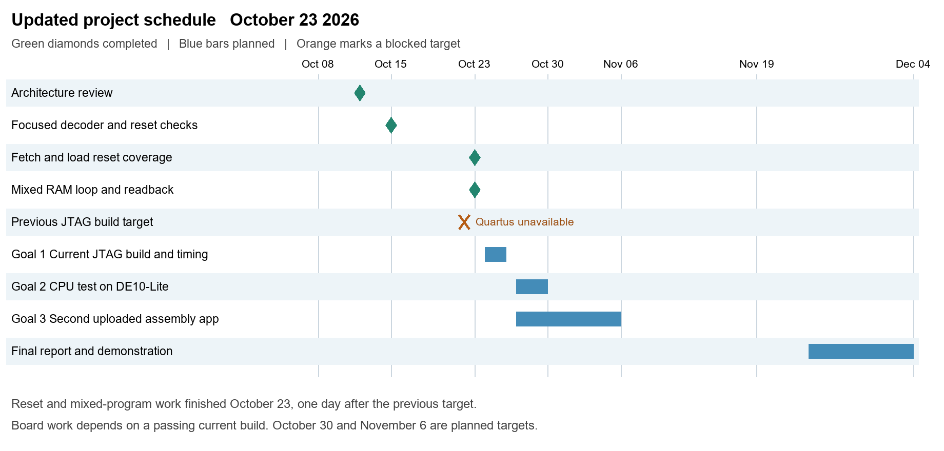
Figure 1. Previous schedule from Report 6, preserved without changes. Build, board and second-application targets were October 26, October 30 and November 6.
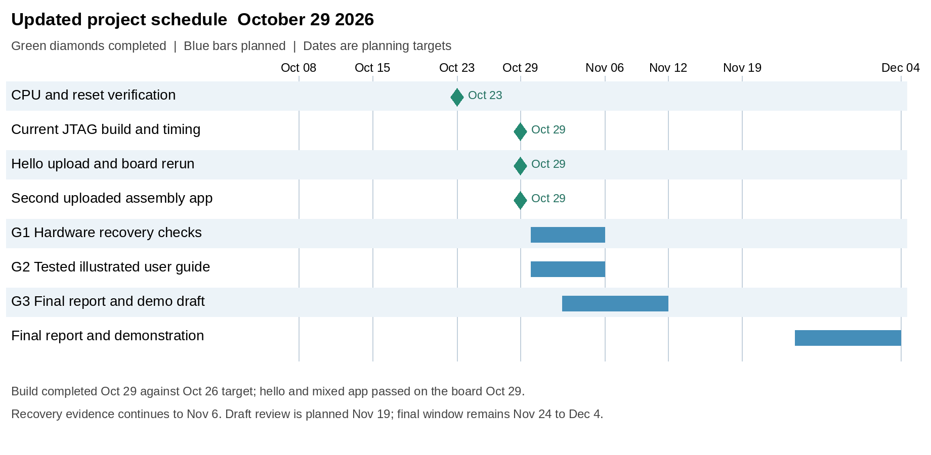
Figure 2. Updated schedule with October 29 completion dates, recovery and guide targets on November 6, and a report/demo draft target on November 12.
The build finished three days after its target; the successful application board tests finished ahead of their targets. The November 19 draft-review checkpoint supports the existing November 24 through December 4 final report and demonstration window.
DE10-Lite board and current FPGA build
I programmed the current design and connected to its ROM loader through the board's USB-Blaster. The photo shows the powered DE10-Lite beside the computer displaying the hello and mixed RAM application results.
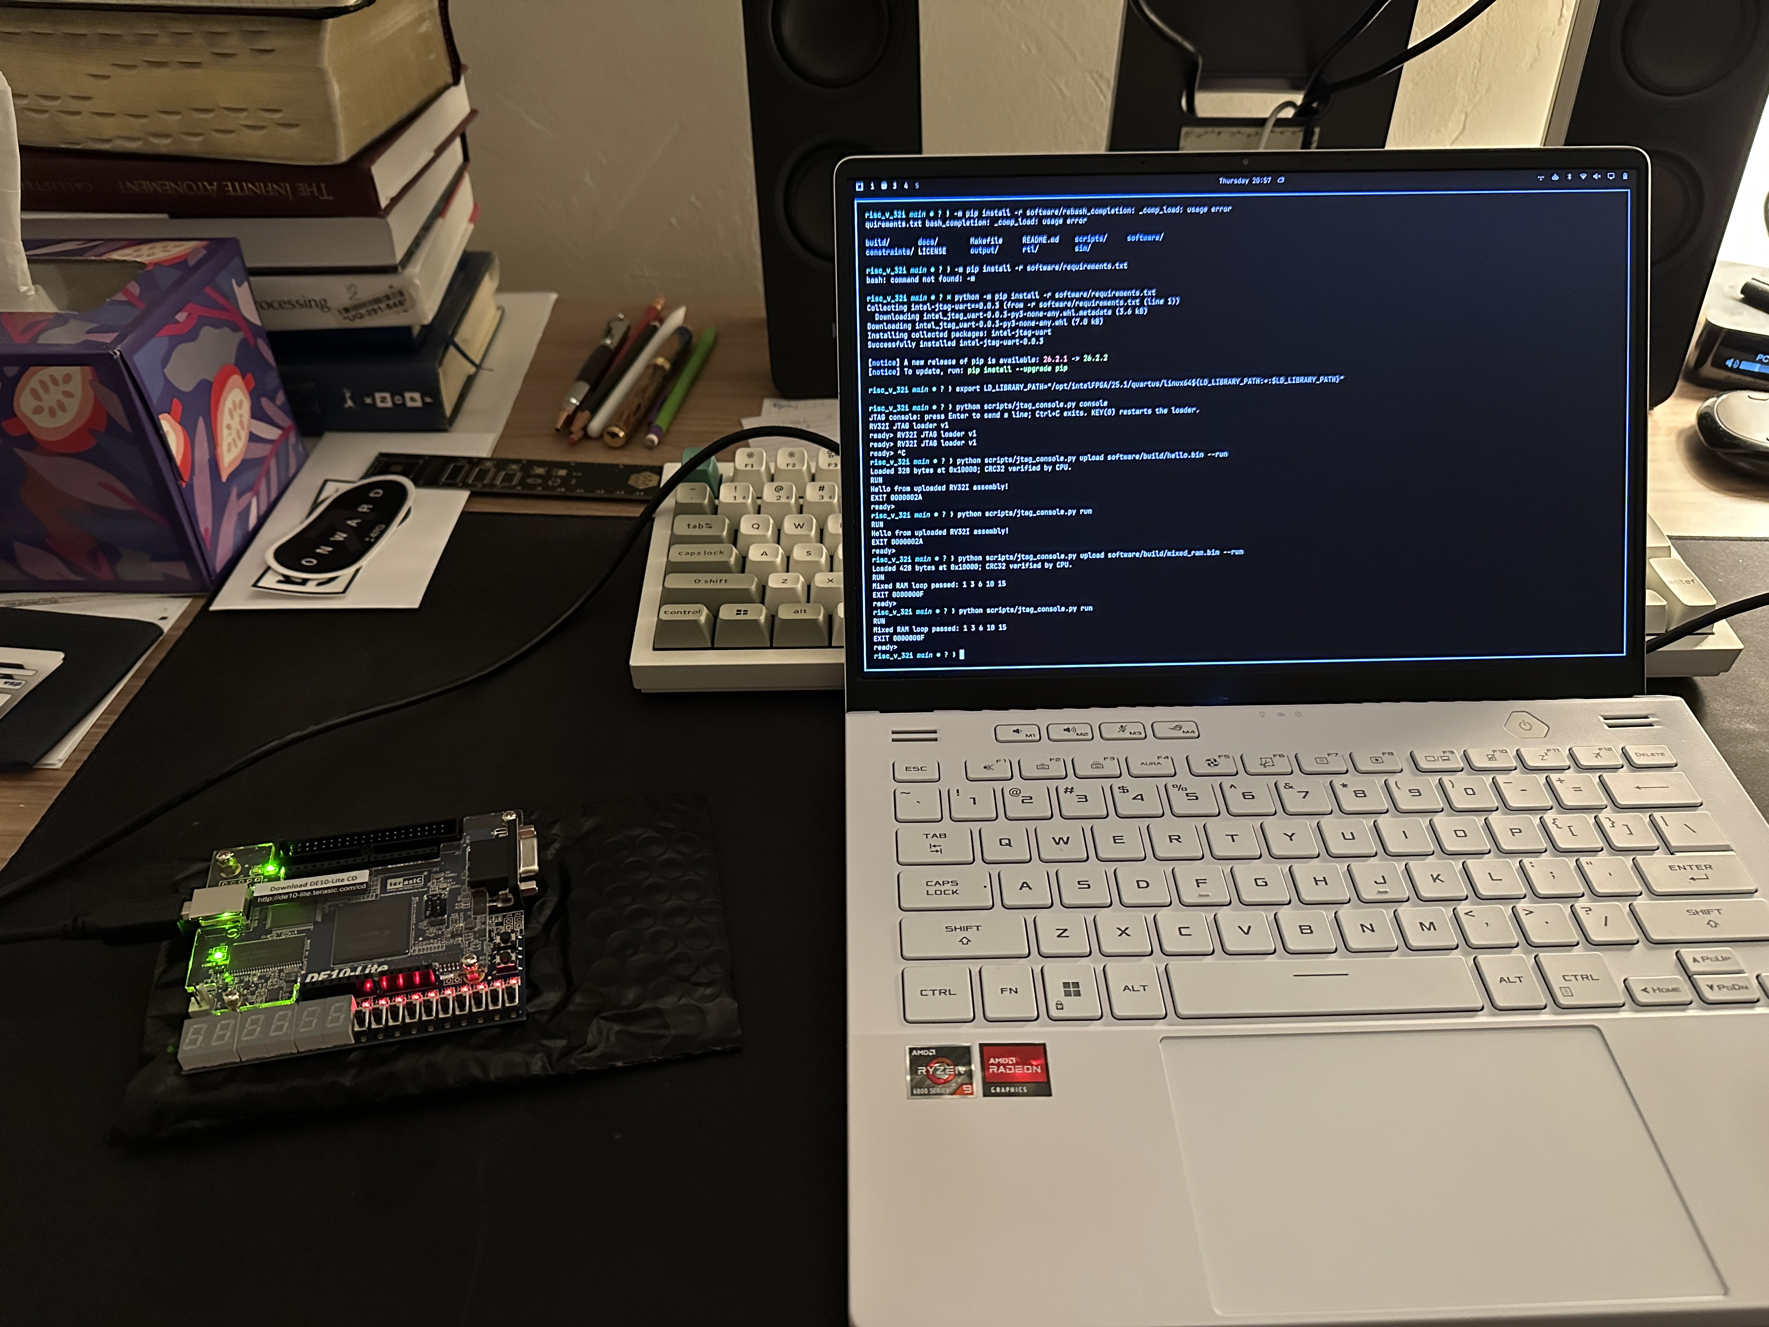
Figure 3. Board photo taken October 29 at 20:57. The DE10-Lite is powered and connected while the computer displays both uploaded application tests.
Build or timing check | October 29 result
Quartus / target | Lite 25.1std.0 build 1129 / MAX 10 10M50DAF484C7G
CPU clock / JTAG timing target | 50 MHz / 10 MHz
Worst setup / hold slack | +2.339 ns / +0.096 ns
Worst recovery / removal slack | +16.793 ns / +0.403 ns
Unconstrained clocks, ports and paths | 0 for setup and hold
Logic / registers / memory | 3,336 logic elements; 1,504 registers; 394,240 memory bits (24%)

Archived build SOF SHA256
9d47f4ddc5c03f823a16a764951a4dad
b9ad7cc92df3df66133d5b12743686fd
Uploaded application results on the board
The console screenshot records loader startup, CRC-verified uploads at 0x10000, and two runs of each application. Each execution returns to ready> without another FPGA compilation.
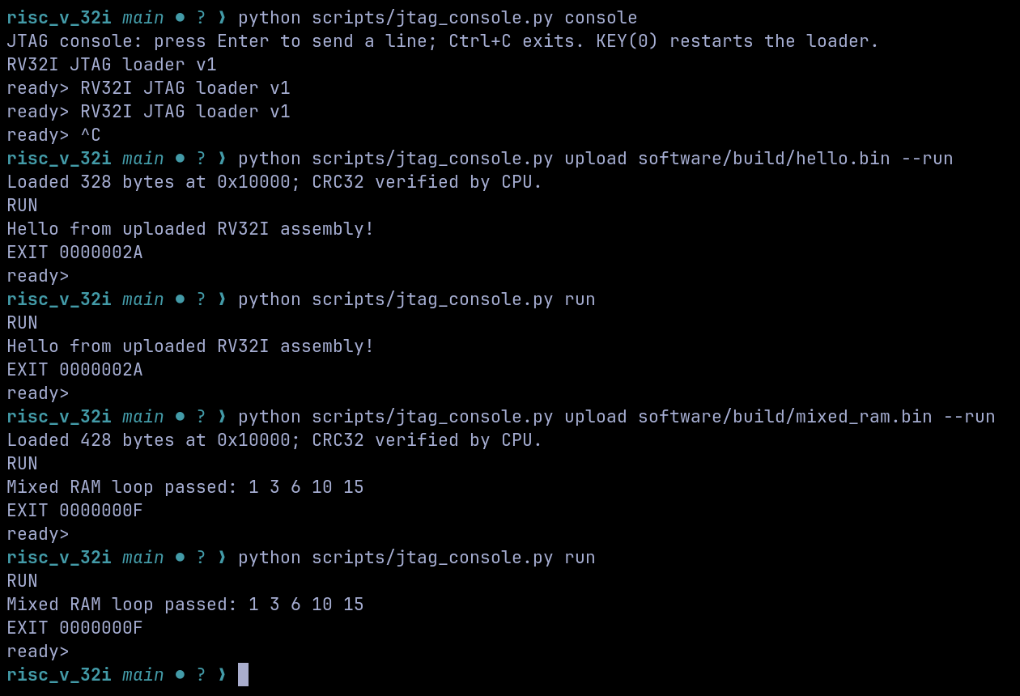
Figure 4. Original October 29 console screenshot. Empty black space at the right is cropped in Word for readability; the archived PNG is unchanged.
Application | Upload size | Observed result
hello.bin | 328 bytes | Hello message; EXIT 0000002A; ready>; successful rerun
mixed_ram.bin | 428 padded bytes | Sums 1 3 6 10 15 pass; EXIT 0000000F; ready>; successful rerun

The mixed RAM program computes running sums, stores and reloads each word, then compares all five final words against fixed expected values. Its printed success message is reached only after those checks pass. The same image also passes the loader integration simulation, including CRC rejection, rerun and reset during upload.
The screenshot shows repeated loader banners before the uploads. A recorded reset-after-upload, fresh-upload recovery, interrupted-transfer recovery and bad-CRC board sequence remain in next week's hardware goal. The five-word RAM check covers this application workload rather than every RAM location.
Evidence: report-7-board-photo.jpg, report-7-console.png, report-7-regression.txt and report-7-timing-check.txt in docs/progress_reports/evidence. Build reports and SOF identity remain in the dated validation records. JTAG timing uses documented 3 ns external I/O assumptions. The console capture does not independently identify the programmed SOF hash.

